Procedure for Continual Improvement

Security Classification: Protected

Document Reference: ISMS10001
Version: 1.0
Draft 1

Document Author:

Document Owner:

Revision History

Version | Date | Change Number | Summary of Changes

Document Review

Date of Next Scheduled Review

Distribution

Name | Title

Approval

Name | Position | Signature | Date

Contents

1 Introduction 5
2 Continual Improvement Process 6
2.1 Process Diagram 6
2.2 Identifying Improvements 7
2.3 Evaluation 7
2.4 Approval and Prioritisation 7
2.5 Management and Review 8

Introduction

In general, the Nigeria Customs Service will use the Plan-Do-Check-Act method (the Deming Cycle) for managing ISMS improvements.

This is driven by the ISMS Policy which is updated on an annual basis and improvement objectives are set based on requirements of business processes and the following inputs:

- Information security policy
- Information security objectives
- Audit results
- Analysis of monitored events.
- Corrective and preventive actions
- Management review

On-going success against these objectives is reviewed at management meetings and any action taken to ensure that the Project Management Office (PMO) is on track to achieving them.

In addition to this annual planning cycle, individual ISMS improvements are identified and implemented throughout the year as ideas and the need arise.

Continual Improvement Process

Process Diagram

The process for identifying and achieving improvements is summarised in the diagram below.

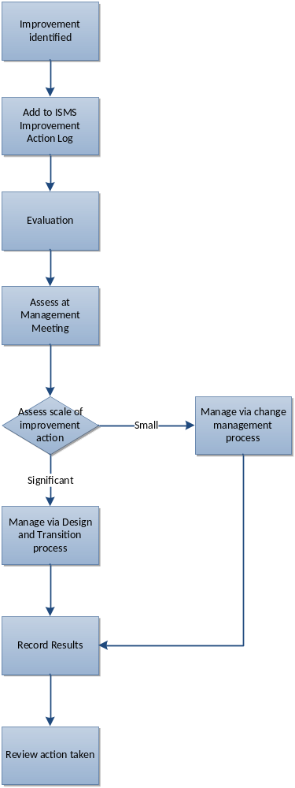

Figure 1 – Continual Improvement Process

The detail of the above steps is described in the following sections.

Identifying Improvements

Improvements may be identified from any source and the ACG ICT-Modernisation will encourage personnel and third parties to propose ways in which they can be found. Such improvements may be identified from:

- Security reviews
- Team meetings
- Risk assessments
- User surveys
- Internal and external audits

However, the above is not an exhaustive list.

Once identified, the improvement will be documented within ISMS10003 ISMS Improvement Action Log with a status of “Logged”. At this stage the action to achieve the improvement has not necessarily been determined. As much detail as possible should be specified as to the exact nature of the proposal.

Evaluation

Once logged, the improvement will be evaluated by the Officer-In-Charge of Continual Improvement to assess its importance and potential benefit and what needs to be done to achieve it. Other parties may be consulted during this stage to understand both the background and the implications and mechanics of making it happen.

Approval and Prioritisation

Once the improvement has been successfully identified it must be determined whether there is sufficient resource to implement it. The expected benefits of the improvement will also be documented in measureable terms where possible.

If the improvement is approved its status is changed to “Approved”.

The improvement action will now be prioritised against the others on the list to determine the relative allocation of resources and the likely timeframe of it. A scale of High, Medium, and Low is used.

Management and Review

Approved improvements will be managed, and actions recorded via the ISMS Improvement Action Log and reviewed on a regular basis. Where the improvement requires a configuration item to be changed, a change request will be raised, and the action will be performed under the control of the change management process. The change request number will be recorded against the ISMS improvement record in the ISMS Improvement Action Log.

For major changes the ISMS improvement process will interface with the Design and Transition of a New or Changed Service process which will ensure the improvement project is managed effectively.

Improvements will be categorised according to the area of the Information Security Management System they impact, and reports produced on the number raised, approved and successfully implemented.

Once implemented, the effect of the improvement will be evaluated against the expected impact. If the benefits expected are not achieved, the reasons for this will be investigated as part of the regular review meeting.

